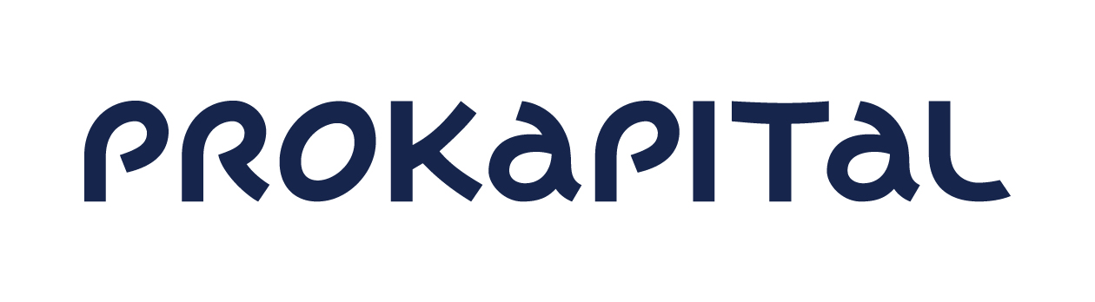
Notice of calling the
ANNUAL GENERAL MEETING of
AS PRO KAPITAL GRUPP
shareholders

Dear shareholder of AS Pro Kapital Grupp,

We announce that the Management Board is calling for the annual general meeting of AS Pro Kapital Grupp (registration code 10278802, located at Sõjakooli 11 Tallinn Republic of Estonia) (hereinafter the Company) shareholders which shall take place on Tuesday, 21th of June, 2022 at 13.00 in the Andante room at Sokos Hotel Viru, Viru väljak 4, 10111 Tallinn Republic of Estonia. Registration of shareholders shall take place from 12.45 - 13.00 on the 21th of June 2022 at the location of the meeting.

The reason for calling the annual general meeting is to decide on approval of the annual report for the financial year of 2021, distribution of the profit, election of the auditor and the remuneration policy for the executive management of Company. The proposal to call the annual general meeting of shareholders was made by the Management Board of the Company.

The agenda of the meeting is as follows:

- Election of the Chairman and Secretary of the annual general meeting of shareholders

The Management Board’s proposal:
Elect Karin Madisson as the Chairman of the annual general meeting of the shareholders. Elect the Secretary of the meeting as per suggestions made at the meeting.

- Approval of the audited annual report of the Company for the financial year of 2021

The Company has prepared the annual report for the financial year of 2021. The report has been audited and the audited report has been made available to the shareholders. It is the competency of the shareholders to approve the annual report.

The Council’s and Management Board’s proposal and draft of the resolution:
Approve the audited annual report of the Company for the financial year of 2021.

- Resolution of distribution of the profit

The Company’s net profit for the financial year which ended 31 December 2021 was in
the amount of 29’756’656 Euros. On the last general meeting it was decided to cover
the net loss of 2020 with reserves and share premium in addition to retained earnings
of previous periods. As per the commercial code it is the shareholders’ competency to
decide on how to distribute profit.

The Council’s and Management Board’s proposal and draft of the resolution:
To distribute the net profit for the financial year which ended 31 December 2021 in the amount of 3,913,201 Euro to recover share premium, in the amount of 1,133,759 Euros to recover the statutory reserve and the rest 24’709’696 Euros into retained earnings of previous periods.

- Election of the auditor
In financial year of 2021 Ernst & Young Baltic AS has provided audit services to the Company in
relation to the audit of the annual report. The auditor has confirmed as required by the
corporate governance recommendations that it has no work, economic or other relations that
would threaten its independence while rendering auditing service.

The Council’s and Management Board’s proposal and draft of the resolution:
Elect Ernst & Young Baltic AS as the auditor of the Company for the financial year of 2022.

- The remuneration policy for the executive management of Company
The remuneration policy for the executive management of Company have been prepared in accordance with the Estonian Securities Market Act, in addition, the recommendations of the Corporate Governance Recommendations have been taken into account. The remuneration policy will be published on the Company's website and is also described in the section of the Company's annual report entitled “Corporate governance report. Management remuneration report“.

The Council’s and Management Board’s proposal and draft of the resolution:
To approve the remuneration policy for the executive management of Company.

According to the Commercial Code § 297 section 5 the set of shareholders entitled to take part in the annual general meeting of shareholders shall be determined as at 7 days before holding the general meeting as at the end of the working day of the settlement system of the registrar of the Estonian register of securities or another depository where the shares of a public limited company are entered, which precedes the general meeting, i.e. on 14th of June, 2022 at end of the working day.

A shareholder has the right to receive information on the activities of the public limited company from the management board at the general meeting. The management board may refuse to give information if there is a basis to presume that this may cause significant damage to the interests of the public limited company. If the management board refuses to give information, the shareholder may demand that the general meeting decide on the legality of the shareholder's request or to file, within two weeks after the general meeting, a petition to a court by way of proceedings on petition in order to obligate the management board to give information.

Shareholders whose shares represent at least 1/20 of the share capital may request adding items to the agenda of the general meeting, if the respective request has been made 15 days before the meeting, i.e. on 6th of June, 2022 at the latest. They may also submit a draft resolution for each item on the agenda at least 3 days before the meeting, i.e. on 18th of June, 2022 at the latest. Please submit the draft resolution in writing to AS Pro Kapital Grupp, Sõjakooli 11, Tallinn, 11316.

At the meeting, items previously not on the agenda may be taken onto the agenda if at least 9/10 of participating shareholders approve and their shares represent at least 2/3 of the share capital (proxy votes will be discounted). A general meeting may decide on calling the next meeting and settle submissions concerning administrative issues related to the agenda or to the procedure for holding the meeting without such matters having to be included on the agenda beforehand, and to discuss other matters without making resolutions.

The shareholder can until 20th of June, 2022 at 16:00 inform the Company of appointing a representative or of renouncing the power of attorney of the representative, by sending the digitally signed notice to prokapital@prokapital.ee or by sending the written notice to the office of the Company at Sõjakooli 11 Tallinn.

The shareholders of the Company can acquaint themselves with the drafts of the resolutions and proposals, the audited annual report of 2021 financial year, the auditor opinion, the remuneration policy for the executive management of Company on the webpage of the Company www.prokapital.com under the sub-section Company, Investor, Shareholders or upon prior request at the location of the Company at Sõjakooli 11 Tallinn at an agreed time during the business days from 09:00 until 17:00. If you have any questions in regards to the annual general meeting of shareholders, please contact us by phone + 372 6 144 920 or by email at prokapital@prokapital.ee. Questions and answers related to the agenda of the shareholders meeting shall be published on the website of the Company www.prokapital.com under the section Company, Investor.

Documents needed to participate at the meeting
Natural person shareholders are kindly asked to bring along a valid identification document, representatives are kindly asked to bring along a valid identification document and a valid written power-of-attorney. In the case of shareholders who are legal entities we request you to bring an extract from the relevant register, where that legal person has been registered and a valid identification document of the representative. For persons representing a legal entity under power of attorney we kindly ask to bring in addition of the referred documents also a valid written power of attorney. Each document issued by a foreign country’s official must be either legalized or authenticated with a document certificate apostille and translated into English.

Proxy voting
It is possible to vote by proxy by submitting the relevant form to the Company before the meeting. The form with instructions is available on the webpage of the Company www.prokapital.com under the sub-section Company, Investor, Shareholders.

Best regards, Management Board of AS Pro Kapital Grupp

