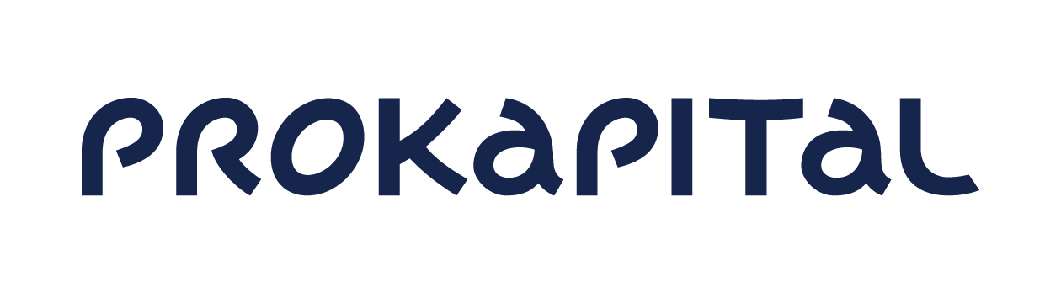
Notice of calling the
ANNUAL GENERAL MEETING of
AS PRO KAPITAL GRUPP
shareholders

Dear shareholder of AS Pro Kapital Grupp,

We announce that the Management Board is calling for the annual general meeting of AS Pro Kapital Grupp (registration code 10278802, located at Sõjakooli 11 Tallinn Republic of Estonia) (hereinafter the Company) shareholders which shall take place on Wednesday, 27 of May 2020 at 13.00 at Tallinn Art Space Gallery, on the ground floor of T1 Mall of Tallinn at Peterburi tee 2, Tallinn, the Republic of Estonia (see www.tallinnartspace.com). Registration of shareholders for the meeting shall take place from 12.45 - 13.00 on the 27 of May 2020 at the location of the meeting.

The reason for calling the annual general meeting is to decide on approval of the annual report for the financial year of 2019, resolution on covering the loss, election and remuneration of the auditor, prolongation of term of two Supervisory Council members, recalling of one and election of one new Council member. The proposal to call the annual general meeting of shareholders was made by the Management Board of the Company.

The agenda of the meeting is as follows:

- Election of the Chairman and Secretary of the annual general meeting of shareholders

The Management Board’s proposal:
Elect Ilona Nurmela as the Chairman of the annual general meeting of the shareholders. Elect the Secretary of the meeting as per suggestions made at the meeting.

- Approval of the audited annual report of the Company for the financial year of 2019

The Company has prepared the annual report for the financial year of 2019. The report has been audited and the audited report has been made available to the shareholders. It is the competency of the shareholders to approve the annual report.

The Councils and Management Boards proposal and draft of the resolution:
Approve the audited annual report of the Company for the financial year of 2019.

- Resolution of covering the loss
The Company’s net loss for the financial year which ended 31 December 2019 was in the amount of 26 981 682 Euros. As per the commercial code it is the shareholders’ competency to decide on the allocation of the profit and/or loss.

The Councils and Management Boards proposal and draft of the resolution:
Cover the net loss for the financial year which ended 31 December 2019 in the amount of
26,981,682 Euros with retained earnings of previous periods.

- Extending the term of office, recalling and election of the Supervisory Council members
Two Supervisory Council members have been elected until 05 July 2020 and one until 22 May 2020. The independent member of the Company’s Supervisory Council, Mr Olkinuora and the Chairman of the Council, Mr Bozzone, have consented to stand for re-election. Mr Ernesto Preatoni does not wish to stand for re-election and his term has ended on 22 May 2020. The Chairman has consulted with the majority shareholders and they have suggested that the presence of a person with legal background on the Council would be beneficial. Thus, the Management Board of the Company is proposing to prolong the term of two existing members and to elect a new third Supervisory Council member as follows:

The Council’s and Management Board’s proposals and draft resolutions:
  - Prolong the term of office of Emanuele Bozzone as a member of the Supervisory Council of the Company for three years until 05 July 2023.
  - Prolong the term of office of Petri Altti Sakari Olkinuora as a member of the Supervisory Council of the Company for three years until 05 July 2023.
  - Elect Oscar Crameri as a member of the Supervisory Council of the Company from 27 May 2020 until 05 July 2023.

CV data and presentation of the Council Members can be accessed on homepage
www.prokapital.com sub-section “the Company”.
Principles and sums of remuneration of members of Supervisory Council remains as decided at 20 June 2016 General Meeting of shareholders.

- Election of the auditor

In financial year of 2019 AS Deloitte Audit Eesti has provided audit services to the Company in relation to the audit of the annual report. In the opinion of the Council the auditor has performed the services in accordance with the agreement and the Council does not have any objections as to the service provided. The auditor has confirmed as required by the corporate governance recommendations that it has no work, economic or other relations that would threaten its independence while rendering auditing service. In 2019, the Management Board of the Company took offers from different audit companies for audit for the next 2 years. The recommendation of the audit committee and the Council in 2019 was to continue the collaboration with AS Deloitte Audit Eesti as their price offer and quality of work is considered to be in the best proportion.

The Council’s and Management Board’s proposal and draft of the resolution:
Elect AS Deloitte Audit Eesti as the auditor of the Company for the financial year of 2020.

To approve the principles for remuneration of the auditor as per the agreement to be signed with the auditor. Approve the fee payable to the auditor for the audit of Company and its subsidiaries for the financial year of 2020 in the amount of 58 300 Euros (net of VAT).

According to the Commercial Code § 297 section 5 the set of shareholders entitled to take part in the annual general meeting of shareholders shall be determined as at 7 days before holding the general meeting as at the end of the working day of the settlement system of the registrar of the Estonian register of securities or another depository where the shares of a public limited company are entered, which precedes the general meeting, i.e. on 20 May 2020 at end of the working day.

A shareholder has the right to receive information on the activities of the public limited company from the management board at the general meeting. The management board may refuse to give information if there is a basis to presume that this may cause significant damage to the interests of the public limited company. If the management board refuses to give information, the shareholder may demand that the general meeting decide on the legality of the shareholder's request or to file, within two weeks after the general meeting, a petition to a court by way of proceedings on petition in order to obligate the management board to give information.

Shareholders whose shares represent at least 1/20 of the share capital may request adding items to the agenda of the general meeting, if the respective request has been made 15 days before the meeting, i.e. on 12 May 2020 at the latest. They may also submit a draft resolution for each item on the agenda at least 3 days before the meeting, i.e. on 24 May 2020 at the latest. The draft resolution should be submitted in writing to AS Pro Kapital Grupp, Sõjakooli 11, Tallinn, 11316.

At the meeting, items previously not on the agenda may be taken onto the agenda if at least 9/10 of participating shareholders approve and their shares represent at least 2/3 of the share capital. A general meeting may decide on calling the next meeting and settle submissions concerning administrative issues related to the agenda or to the procedure for holding the meeting without such matters having to be included on the agenda beforehand, and to discuss other matters without making resolutions.

The shareholder can until 26 May 2020 at 16:00 inform the Company of appointing a representative or of renouncing the power of attorney of the representative, by sending the digitally signed notice to prokapital@prokapital.ee or by sending the written notice to the office of the Company at Sõjakooli 11 Tallinn.

The shareholders of the Company can acquaint themselves with the drafts of the resolutions and proposals, the audited annual report of 2019 financial year, the auditor opinion, on the webpage of the Company www.prokapital.com under the sub-section Company, Investor, Shareholders or upon prior request at the location of the Company at Sõjakooli 11 Tallinn at an agreed time during the business days from 09:00 until 17:00. If you have any questions in regards to the annual general meeting of shareholders, please contact us by phone + 372 6 144 920 or by email at prokapital@prokapital.ee. Questions and answers related to the agenda of the shareholders meeting shall be published on the website of the Company www.prokapital.com under the section Company, Investor.

Documents needed to participate at the meeting
Natural person shareholders are kindly asked to bring along a valid identification document, representatives are kindly asked to bring along a valid identification document and a valid written power-of-attorney. In the case of shareholders who are legal entities we request you to bring an extract from the relevant register, where that legal person has been registered and a valid identification document of the representative. For persons representing a legal entity under power of attorney we kindly ask to bring in addition of the referred documents also a valid written power of attorney. Each document issued by a foreign country’s official must be either legalized or authenticated with a document certificate apostille and translated into English.

Best regards, Management Board of AS Pro Kapital Grupp

